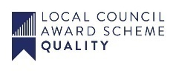
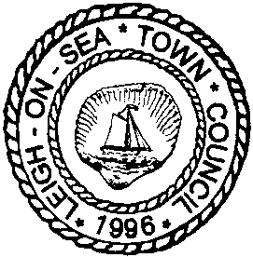
Leigh-on-Sea Town Council

71-73 Elm Road, Leigh-on-Sea, Essex SS9 1SP | Tel: 01702 716288
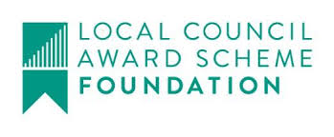
council@leighonseatowncouncil.gov.uk | www.leighonseatowncouncil.gov.uk

Application for Artist in Residence
April 2023 – April 2024

Please complete the following forms to support your application. The information supplied will form the basis for the interview discussion along with the presentation of your portfolio.

The completed application form is to be sent to council@leighonseatowncouncil.gov.uk
or by post to Leigh Community Centre, 71 – 73 Elm Road, Leigh-on-Sea, SS9 1SP

Name/s:
(The residency could be a collaboration between two artists or a small group)
Address:
(contact details for lead applicant only)
Email:
Telephone:
Date of Birth:
(minimum age 18 for all applicants)
Artist Social Media and Website Details

February availability for interviews
Signature |  | Date:
☐ Tick box to confirm that you have read and agree to the Artist in Residence Brief and Terms and Conditions

Please ensure that you supply a varied sample of your work when making your application

Why do you want to be Leigh Community Centre’s “Artist in Residence”?
What is your area of artistic interest and how would you use the Artist in Residence opportunity to develop it?

What can you offer the Leigh Community?
The Artist in Residence initiative is part of Leigh-on-Sea Town Council’s commitment to promote educational and cultural facilities/activities within the Town for the benefit of the community and visitors.

What experience do you have in working with the general public?

